Analog Electronics

5 Topics are

1. Diodes and BJT
2. Transistor Biasing and Frequency Response
3. FET Amplifiers and Power Amplifiers
4. Oscillators
5. Op-amps and Its Applications

# Diodes and BJT

* 1. In a pnp-BJT, when the E-B junction is forward biased and no voltage is applied across C-B junction, what happens to the width of the depletion region in the E-B junction?
     1. Increases
     2. Decreases
     3. Remains same
     4. Can’t be determined Ans) b
  2. What is the value of the voltage equivalent of temperature at room temperature (27oC)?
     1. 26mV
     2. 36mV
     3. 0.26mV
     4. 260mV Ans) a
  3. If the diffusion capacitance is directly proportional only to the lifetime of holes in N side, then
     1. The diode is a p+n junction diode
     2. The diode is a pn+ junction diode
     3. The diode is a p+n+ diode
     4. The diode can have any type of pn junction Ans) a
  4. The diode current equation is not applicable in
     1. Forward biased state
     2. Reverse biased state
     3. Unbiased state
     4. It is applicable in all bias states Ans) d
  5. If peak voltage on a center tapped full wave rectifier circuit is 5V and diode cut-in voltage is 0.7, then peak inverse voltage on diode will be
     1. 4.3 V
     2. 10 V
     3. 5.7 V
     4. 9.3 V Ans) d
  6. Consider the circuit provided. Total discharge time = 0.5 ms. Consider the diode to be an ideal diode, for a square wave input of ± 10 V, what is the percentage tilt? (C = 1MF & R

= 50k Ohms)

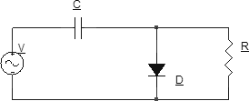

a) 10%

b) 1%

c) 0.1%

d) 1.1%

Ans) b

# Transistor Biasing and Frequency Response

1. Given that transition capacitance is 5 pico F and diffusion capacitance is 80 pico F, and base emitter dynamic resistance is 1500 Ω, find the β cut-off frequency.
   1. 7.8 x 106 rad/s
   2. 8.0 x 106 rad/s

c) 49.2 x 106 rad/s

d) 22.7 x 106 rad/s Ans) a

1. Gain bandwidth frequency is GBP= 3000 Mhz. The cut-off frequency is f=10Mhz. What is the CE short circuit current gain at the β cutoff frequency?

a) 212

b) 220

c) 300

d) 200

Ans) a

1. Given a MOSFET where gate to source capacitance is 300 pF and gate to drain capacitance is 500 pF. Calculate the gain bandwidth product if the transconductance is 30 mΩ-1.
   1. 5.98 Mhz
   2. 4.9 Mhz
   3. 6.5Mhz
   4. 5.22Mhz Ans) a
2. What is the phase shift in RC coupled CE amplifier at lower 3dB frequency? a) 180°

b) 225°

c) 270°

d) 100°

Ans) b

1. We cannot use h-parameter model in high frequency analysis because _
   1. They all can be ignored for high frequencies
   2. Junction capacitances are not included in it
   3. Junction capacitances have to be included in it
   4. AC analysis is difficult for high frequency using it Ans) b
2. In Miller’s theorem, what is the constant K?
   1. Total voltage gain
   2. Internal voltage gain
   3. Internal current gain
   4. Internal power gain Ans) b

# FET Amplifiers and Power Amplifiers

1. The built-in barrier potential in a N-channel JFET is
   1. less than the internal pinch-off voltage
   2. equal to the internal pinch-off voltage
   3. greater than the internal pinch-off voltage
   4. not related to the internal pinch-off voltage Ans) a
2. Assume µnCox = 100 µA/V2 and supply current is 5mA, what should be the aspect ratio so that a 50 Ω load can be used to give a voltage gain of .25 in C.D. configuration?

a) 32.6

1. 50
2. 40
3. 41 Ans) a
4. Neglecting Channel Length Modulation, what is the output impedance of the following

C.S. stage?

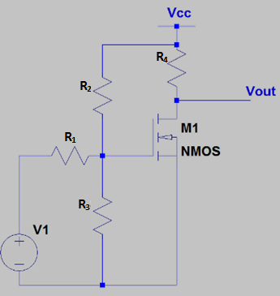

1. R4
2. R4 || R2

c) R4 || (R2 + R3)

d) R4 || [(R2 + R3) || R1] Ans) a

1. The current gain of a simple CG stage is approximate
   1. Infinity
   2. unity
   3. twice
   4. 0 Ans) b
2. The unwanted characteristics of amplifier output apart from the desired output is collectively termed as
   1. Inefficiency
   2. Damage
   3. Fault
   4. Distortion Ans) d
3. Power amplifier directly amplifies _
   1. Voltage of signal
   2. Current of the signal
   3. Power of the signal
   4. All of the mentioned Ans) d

# Oscillators

1. Frequency of oscillation of alternator is
   1. 100Hz
   2. 50Hz
   3. 1KHz
   4. 200Hz Ans) b
2. Frequency of oscillation for three section RC phase shift network is given by

a) 1/(ᴨ√6 RC)

b) 2/(ᴨ√6 RC)

c) 1/(2ᴨ√6 RC)

d) 1/(2√6 RC)

Ans) c

1. At the resonant frequency, what is the phase shift for the output in a Wien Bridge oscillator?
   1. 0°

b) 45°

c) 90°

d) 180°

Ans) a

1. 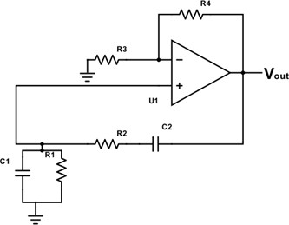The following circuit is provided. R1=R2 and C1=C2.

What is the correct choice for sustained oscillation?

* 1. R1 = R2
  2. R4 = 2R3
  3. R4 = 3R3

d) R1 = R2 = R3 = R4

Ans) b

1. Recommended frequency range of Hartley oscillator is
   1. 30KHz-30MHz
   2. 1KHz-10MHz
   3. 2Hz-3MHz
   4. 0.5KHz-40MHz Ans) a
2. What will be the oscillator frequency of Hartley oscillator if inductance L1, L2 are equal to 1mH and 2mH respectively and capacitor C is 10nF. (Neglect mutual inductance)
   1. 50KHz
   2. 29KHz
   3. 40KHz
   4. 57 kHz

Ans) b

# Op-amps and its applications

1. Given that for an op-amp the gain is 103, the slew rate is 1.5V/μsec. Input is 5×10-3sinωt, calculate maximum frequency to prevent distortion.
   1. 47.7 kHz
   2. 0.3 MHz
   3. 477 Hz
   4. 3 kHz Ans) a
2. Given that CMRR is 100dB. Input common-mode voltage is 12 V. Differential voltage gain is 4000. Calculate output common-mode voltage.
   1. 48V

b) 0.48V

1. 20V
2. 11V Ans) b
3. The current flowing into one input of the op-amp is 12nA and it is 10 nA in the other. Find the input offset current.
   1. 1nA
   2. 2nA
   3. -2nA
   4. 11nA Ans) b
4. Given that the PSRR of an op-amp is 120dB. The supply lies between 12V to 15V. Calculate the change in the input offset voltage.
   1. 3μV
   2. ±3μV

c) ±3×10-12V

d) -3V Ans) b

1. Find the cutoff frequency for the following circuit. (R1=R2=20kΩ)

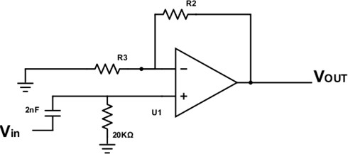

* 1. 25 kHz
  2. 3987 rad/sec
  3. 2500 Hz
  4. 25000 rad/sec Ans) d

1. When the input frequency is equal to the cutoff frequency, how much is the phase shift in the output?

a) 180°

b) -135°

c) -45°

d) 135°

Ans) d